**Use Case Diagram  
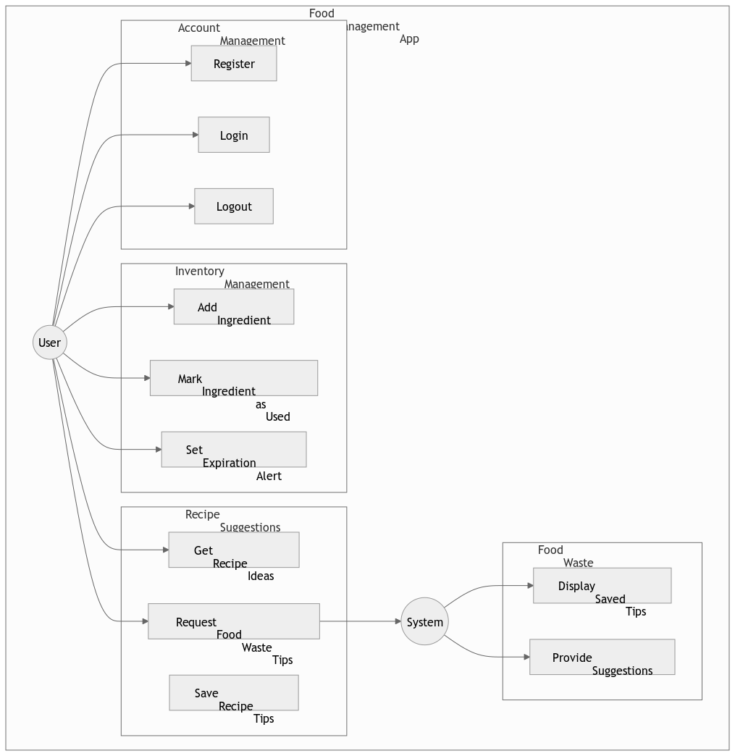  
  
Use Case Specification**

**Use Case Name: Register / Login**  
**Actor(s):** User, System  
**Brief Description:**  
This use case allows users to create an account or log in to access the app.

**Basic Flow:**

1. The user enters login credentials or chooses to register.
2. The system verifies the credentials.
3. If valid, the user is logged in; otherwise, an error message is displayed.

**Alternative Flow:**

* If the credentials are incorrect, the system notifies the user and prompts for re-entry.

**Pre-conditions:**

* The user must have the app installed.

**Post-Conditions:**

* The user is successfully authenticated and granted access to the system.

**Use Case Name: Add Ingredients to Inventory**  
**Actor(s):** User, System  
**Brief Description:**  
This use case allows users to add food ingredients to their inventory for tracking.

**Basic Flow:**

1. The user enters the ingredient name, quantity, and expiration date.
2. The system saves the ingredient in the inventory.

**Alternative Flow:**

* If the ingredient already exists, the system updates the quantity instead of creating a duplicate entry.

**Pre-conditions:**

* The user must be logged in.

**Post-Conditions:**

* The ingredient is stored and visible in the inventory.

**Use Case Name: View Suggested Recipes**  
**Actor(s):** User, System, External Recipe API  
**Brief Description:**  
This use case allows users to get personalized recipe suggestions based on available ingredients.

**Basic Flow:**

1. The user requests recipe suggestions.
2. The system gathers available ingredients.
3. The system sends the ingredient list to an external Recipe API.
4. The external API returns suitable recipes.
5. The system displays the suggested recipes.

**Alternative Flow:**

* If no suitable recipes are found, the system notifies the user and suggests adding more ingredients.

**Pre-conditions:**

* The user must have added ingredients to the inventory.

**Post-Conditions:**

* The user receives relevant recipe suggestions.

**Use Case Name: Mark Ingredients as Used**  
**Actor(s):** User, System  
**Brief Description:**  
This use case allows users to remove ingredients from their inventory after use.

**Basic Flow:**

1. The user selects an ingredient from the inventory.
2. The system removes the selected ingredient from the list.

**Alternative Flow:**

* If the user tries to remove an ingredient that doesn't exist, the system displays an error message.

**Pre-conditions:**

* The user must be logged in.
* The ingredient must exist in the inventory.

**Post-Conditions:**

* The ingredient is no longer available in the inventory.

**Use Case Name: Set Expiration Alerts**  
**Actor(s):** User, System  
**Brief Description:**  
This use case notifies users when ingredients are nearing expiration.

**Basic Flow:**

1. The system periodically checks expiration dates of stored ingredients.
2. If an ingredient is nearing its expiration date, the system sends a notification to the user.

**Alternative Flow:**

* If the user has disabled notifications, the system does not send alerts.

**Pre-conditions:**

* The user must have ingredients with expiration dates in their inventory.

**Post-Conditions:**

* The user is informed about soon-to-expire ingredients.

**Use Case Name: Get Food Waste Tips**  
**Actor(s):** User, System  
**Brief Description:**  
This use case provides users with tips on reducing food waste.

**Basic Flow:**

1. The user requests food waste tips.
2. The system retrieves and displays waste reduction suggestions.

**Alternative Flow:**

* If there are no new tips available, the system shows previously saved tips.

**Pre-conditions:**

* The user must be logged in.

**Post-Conditions:**

* The user gains knowledge on how to minimize food waste.